Table of Contents
Background and Introduction 2
The NAP is structured around five core pillars that guide implementation: 2
Currently, the GBV sector in Yukon operates in an environment characterized by: 2
Methodology and Overview 3
Approaches Used in the Review Process 3
Methodological Adaptations 4
Detailed Core Findings 5
3.1 NAP Reporting Dependencies and GBV Data Challenges 5
Structural Challenges in Data Collection 5
Overview of Annex D 6
Current Data Collection Challenges 7
Imperative for a Mixed Measurement Framework 7
3.2 Funding Model Instability: Project-Based vs. Operational Funding Challenges 8
Systemic Challenges Created by Funding Structure 10
3.3 Economic Impact of the NGO Sector 12
3.4 Implementation Burden and Structural Risks 15
Manifestations of an Unbalanced Implementation Model 15
3.5 Measurement Systems: Current State Assessment 16
The Practical Impossibility of Annex D Measurement in Yukon 17
Analysis and Implications 17
4.1 NAP Implementation Tensions 17
Comprehensive Framework vs. Limited Infrastructure 17
Standardized Metrics vs. Emerging Baselines 18
Pillar-Specific Funding vs. Integrated Service Delivery 18
Cost-Sharing Challenges in Rural Contexts 18
4.2 Government Transparency and NAP Compliance Framework 18
Current Government Reporting Limitations 18
Compliance Verification Challenges 19
NAP Pillar Integration Issues 20
Strategic Decision-Making Impacts 20
4.3 NGO Governance and Accountability: Challenges and Opportunities 20
Impact of Legislative Changes 21
Capacity and Governance Challenges 21
Opportunities for Strengthened Accountability 22
4.4 Economic Transparency: Beyond Service Accountability 22
Economic Framing of Transparency 22
Strategic Implications of an Economic Framing of Transparency 23
4.5 Cross-Sector Transparency Framework: A Proposed Model 24
Governmental Transparency Components 24
Non-Governmental Transparency Components 25
Cross-Sector Integration Mechanisms 25
Recommendations for Years 3 & 4 of NAP GBV Yukon Funds 27
1. Formalize and Sustain Collective Impact Measurement Infrastructure 27
2. Reform Funding Structures to Provide Multi-Year Core Operational Support 28
3. Establish a Collaboration & Data Capacity Pool 29
4. Establish Robust Financial Transparency & Standardization 30
5. Develop Sector Governance & Board Compensation Standards 30
6. Create Explicit Institutional Memory & Succession Planning 31
7. Implement Sector-Wide Salary Equity Review 31
8. Develop Cross-Sector Data Sharing and Coordination 32
9. Develop Scenario-Based Financial Risk Management Protocols 32
10. Formalize Emergency Preparedness & Continuity Planning 32
11. Proactively Address Emerging AI & Digital Literacy Needs 33
12. Adopt Integrated NAP Pillar Indicators 33
13. Implementation Timeline and Milestones 34
Conclusion and Next Steps 35
Immediate next steps include: 35
About Boreal Logic 37
References 39
Appendix A 43
Methodology 43
Appendix B 51
Annex D Indicators vs. Yukon Women's Coalition Deliverables: Feasibility & Alignment Gap Analysis 51
Appendix C 54
Briefing Note: Measuring the Contribution of the Non-Profit and NGO Sector to Yukon's GDP – A Case for Centralized Coordination 54
Appendix D 59
Briefing Note for Yukon Third-Party Recipients: Clarification on Administrative Costs Under the Canada-Yukon NAP GBV Bilateral Agreement 59
Appendix E 61
Societies in Canada Requiring an annual return, including financial information, with a Corporate Registries Office 61

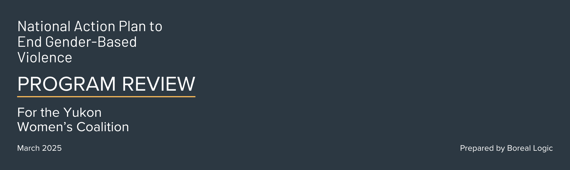

Background and Introduction
The National Action Plan (NAP) to End Gender-Based Violence (WAGE, 2022a) represents a significant federal commitment to addressing one of Canada's most persistent and harmful social challenges. In the Yukon, the implementation of this plan is particularly critical given the territory's disproportionately high rates of gender-based violence compared to national averages (Perreault, 2020). The Yukon Women's Coalition (YWC), as the collective voice of organizations addressing gender-based violence (GBV) across the territory, has a key role in ensuring that federal investments to end GBV translate into meaningful improvements in prevention, response, and long-term systems change.
Despite being a 10-year National Action Plan, the current bilateral agreement between the Government of Canada and the Government of Yukon is only in place until March 2027 (see WAGE, 2022b). This creates a limited window of opportunity for implementing sustainable changes within the current funding framework. Given current political and economic contexts, uncertainty about the NAP’s trajectory beyond 2027 adds urgency to the implementation of years 3 and 4.
The relationship between the Government of Yukon and third-party service providers is central to understanding the current implementation challenges. While policy direction and funding allocation decisions rest with territorial authorities, the delivery of services, collection of essential data, and direct engagement with survivors predominantly occurs through non-governmental organizations (NGOs; described as third party entities). This implementation model creates both challenges and opportunities for effective service delivery, especially in rural and remote communities.

The NAP is structured around five core pillars that guide implementation:
- Support for Victims and Survivors
- Prevention
- Responsive Justice and Policing
- Indigenous-Led Approaches
- Social Infrastructure and Enabling Environment
- The Foundation
The bilateral agreement between Yukon and the federal government establishes a shared cost model, where the federal government covers 50% of eligible expenses, and the Government of Yukon must match the other 50%. The cost-sharing structure between these two governments creates financial interconnectedness that must be thoughtfully managed to ensure sustainability (WAGE, 2022b).

Currently, the GBV sector in Yukon operates in an environment characterized by:
- Fragmented funding that is structured based on short-term projects rather than sustainable operations
- Inconsistent data collection practices that are not supportive of collective impact and/or comprehensive evaluation
- Limited clarity on how territorial funds align with NAP priorities
- Structural inequities that place disproportionately burden third-party organizations with NAP implementationA lack of recognition in policy and funding decisions of the significant economic impact of the GBV sector
- An administrative cap of 10% that limits overhead funding
- A requirement that at least 25% of funding be dedicated to prevention initiatives

The Yukon Women's Coalition hired Boreal Logic to conduct a comprehensive review of NAP implementation in the Yukon. Unlike traditional evaluations that focus on individual organizational performance and outcomes, this review deliberately zooms out to examine systemic patterns, structural gaps, and strategic opportunities across the GBV service landscape in the territory. The assessment comes at a critical juncture as the Women and Gender Equity Directorate (WGED) prepares its strategy to enact Years 3 and 4 of the NAP bilateral agreement. This report provides a strategic framework for addressing identified challenges while harnessing emerging opportunities to strengthen Yukon's approach to GBV prevention and response.

Methodology and Overview
This program review employed a multi-method approach designed to capture both financial patterns (quantitative) and implementation experiences (qualitative) across the GBV sector. We will provide an overview of the methodology and process within this report, but a more detailed description is available in Appendix A. As previously mentioned, the methodology was developed to target systemic patterns, structural barriers, and cross-cutting opportunities that affect the sector as a whole, rather than focus on individual organization function.

Approaches Used in the Review Process
Document Analysis | A comprehensive examination of the Government of Yukon's public accounts, departmental reports, financial statements, YWC work plans and deliverables, and the bilateral agreement between Yukon and the federal government. This analysis specifically focused on how funding flows through the system, the various reporting mechanisms, and the alignment of initiatives with NAP pillars and requirements.
Financial Pattern Analysis | A detailed examination of funding structures, including the ratio of project-based to operational funding, the relationship between deliverables in third-party work plans and operational funding, and the economic multiplier effect of government investments in third-party organizations.
Stakeholder Consultations | Semi-structured interviews with executive directors/frontline staff and a community-based survey focused on implementation challenges, data collection practices, and perceived gaps in current approaches.
Indicator Framework Development | The creation of a customizable measurement system with 24 categories of indicators that can be used to track progress across NAP pillars while promoting adaptation to local contexts and organizational capacities.
Governance Analysis | An examination of accountability structures within the Government of Yukon and among third-party service providers, with particular attention given to the impact of recent changes to the Yukon Societies Act on transparency and governance.
Throughout the process, several methodological adaptations were necessitated, which yielded a shift in approach and insights that ultimately shaped the findings.

Methodological Adaptations
Data Access Opportunities | Sector Cohesion as a Development Indicator | Financial Reporting Enhancement Areas
The timeline for receiving data from YWC organizations created an opportunity to diversify data sources. Shifting to different data sources led to valuable alternative approaches including secondary financial analysis. | Varying levels of participation and information sharing across organizations provided important insights into the YWC’s current collaborative ecosystem. These patterns informed our understanding of current challenges and shaped recommendations for strengthening collective impact and measurement systems. | Understanding of the current financial disclosure landscape revealed opportunities to develop more consistent reporting practices, particularly among organizations managing significant NAP funding. Bolstering analysis with publicly available financial information highlighted potential areas where standardized transparency frameworks could benefit the entire sector.
These methodological adaptations reflect our commitment to developing practical, implementable recommendations grounded in the complex realities of Yukon's GBV sector. They also underscore the value of flexible, responsive evaluation approaches when examining systems-level challenges.
The analysis was guided by several key principles:
- Highgrading practical, actionable solutions over theoretical frameworks
- Recognizing the interdependence government and NGO entities in effective NAP implementation and evaluation
- Acknowledging the unique northern, remote, and rural context of service delivery in theYukon
Limitations of this review include the capacity limitations of the YWC (high turnover etc.), limited availability of standardized data across organizations, and variations in financial reporting practices. Despite these constraints, clear patterns emerged that inform the findings and recommendations presented in this report.

Detailed Core Findings

3.1 NAP Reporting Dependencies and GBV Data Challenges

Structural Challenges in Data Collection
The National Action Plan (NAP) implementation framework highlights substantial structural issues within the Government of Yukon's ability to meet its federal reporting obligations on gender-based violence (GBV). The bilateral agreement outlines detailed outcome indicators (Annex D), yet Yukon faces significant challenges in fulfilling these requirements due to fundamental gaps in quality GBV data (see Appendix B for more fulsome discussion). The Yukon Government itself does not directly collect much of the required data, instead depending heavily on third-party organizations. These organizations are typically inconsistently funded, significantly under-resourced, and often lack the capacity necessary to undertake comprehensive data collection, which creates a reporting contradiction. This situation is exacerbated in rural, remote, and northern contexts, where data infrastructure and resources are even more limited.

The NAP Reporting Contradiction
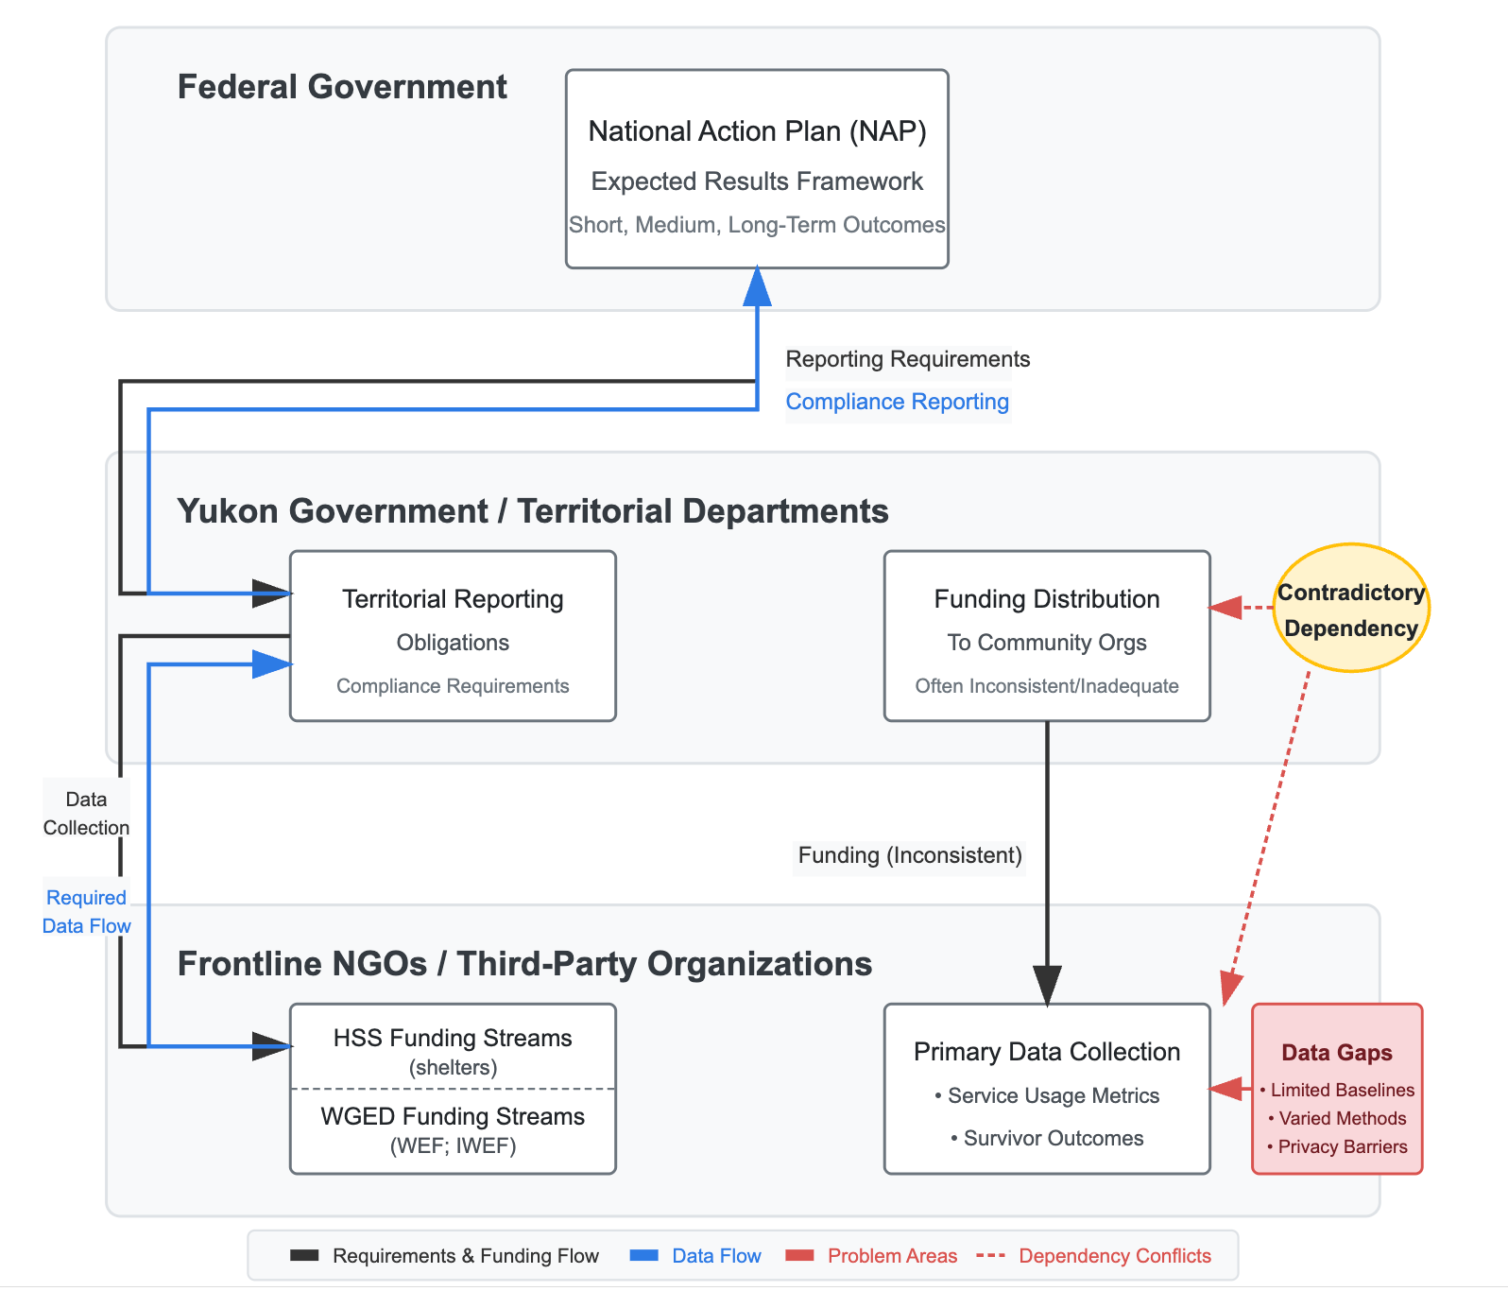
This diagram above illustrates the interconnected relationship between funding allocation and data collection in Yukon's gender-based violence response framework. Frontline NGOs contribute essential data to fulfil territorial reporting needs, yet face resource constraints due to funding variability. This creates a challenging dynamic where service providers balance direct client support with data collection responsibilities.

Overview of Annex D
Annex D (WAGE, 2023) serves as the evaluation blueprint for federal NAP GBV funding in Yukon, specifying standardized yet adaptable reporting requirements across three outcome tiers:
- Short-Term Outcomes: Increased diversity and quantity of GBV initiatives, improved accessibility of victim/survivor services, and enhanced trauma-informed staff training.
- Medium-Term Outcomes: Strengthened capacity and sustainability among Indigenous- and community-led organizations, reduced service barriers for marginalized populations, and improved data quality and consistency across jurisdictions.
- Long-Term Outcomes: Observable reductions in GBV incidence and severity, improved well-being and justice outcomes for survivors, and systemic improvements in institutional responses.

Current Data Collection Challenges
The inherent lack of quality GBV data in Yukon significantly undermines the territory's ability to address GBV effectively. Key data challenges include:
- Absence of Baseline Data: Most required metrics for Yukon's NAP reporting lack established baselines, preventing meaningful tracking of progress.
- Inconsistent Data Collection Issues: Data collection practices vary widely across Yukon Government departments and third-party organizations, resulting in fragmented and unreliable data.
- Funding Shortfalls: Monitoring and evaluation efforts at both governmental and community levels are chronically underfunded, limiting the ability to capture comprehensive GBV data.
- Privacy Concerns: Small community sizes in Yukon amplify privacy risks related to sensitive GBV data, creating additional barriers to effective data sharing and collection.
- Measurement Tool Shortage: There is a significant scarcity of measurement tools designed specifically for rural, remote, and northern contexts, hindering the effective assessment of GBV prevalence and impact.

Limited Direct Measures of GBV Data
While governmental and non-governmental organizations do collect some direct measures of GBV, these sources are limited and fail to capture the full scope:
- Crisis Line Data: Provides call volumes and demographics but misses unreported or ongoing cases.
- Shelter Occupancy and Waitlists: Indicates immediate shelter demand but neglects individuals unable or unwilling to seek shelter.
- SART Participation and Survivor Outcomes: Offers insights into survivor experiences and coordinated responses, but only captures survivors accessing these specific services.

Imperative for a Mixed Measurement Framework
To mitigate these severe data limitations, especially within Yukon's unique geographic and cultural context, a flexible, comprehensive measurement framework is necessary - identified within the definitions of the Yukon’s bilateral agreement itself. Such a framework should integrate direct GBV measures with strategically selected proxy indicators:
- Service Accessibility Metrics: Data such as travel times and service utilization rates highlight barriers and gaps in service accessibility.
- Community Engagement Levels: Tracking participation in prevention programs and community feedback to evaluate the effectiveness of outreach and awareness efforts.
- Economic Impact Indicators: Employment and economic dependency ratios among GBV survivors to illuminate the broader economic consequences of GBV.
- Healthcare Utilization Patterns: Analysis of healthcare visits related to GBV, providing insights into associated health impacts and systemic healthcare responses.
- Safety and Security Measures: Law enforcement calls related to GBV and the availability of emergency interventions to capture immediate safety responses.
Implementing this mixed framework will enable Yukon to better bridge existing data gaps, enhance its capacity to fulfill NAP reporting requirements, and effectively tailor GBV interventions to its distinctive local contexts.

3.2 Funding Model Instability: Project-Based vs. Operational Funding Challenges
Through undertaking this review, we identified a critical structural weakness in the current funding approach that underscores the NAP's implementation in the Yukon. Specifically, there is an absence of a clear, stable funding model that prioritizes operational sustainability over project-specific deliverables. Analysis of historical reports and recommendations emanating from YWC organizations amplified this finding, establishing that the call to shift from project-focused deliverables to more stable core funding has been an ongoing concern present even before the NAP. 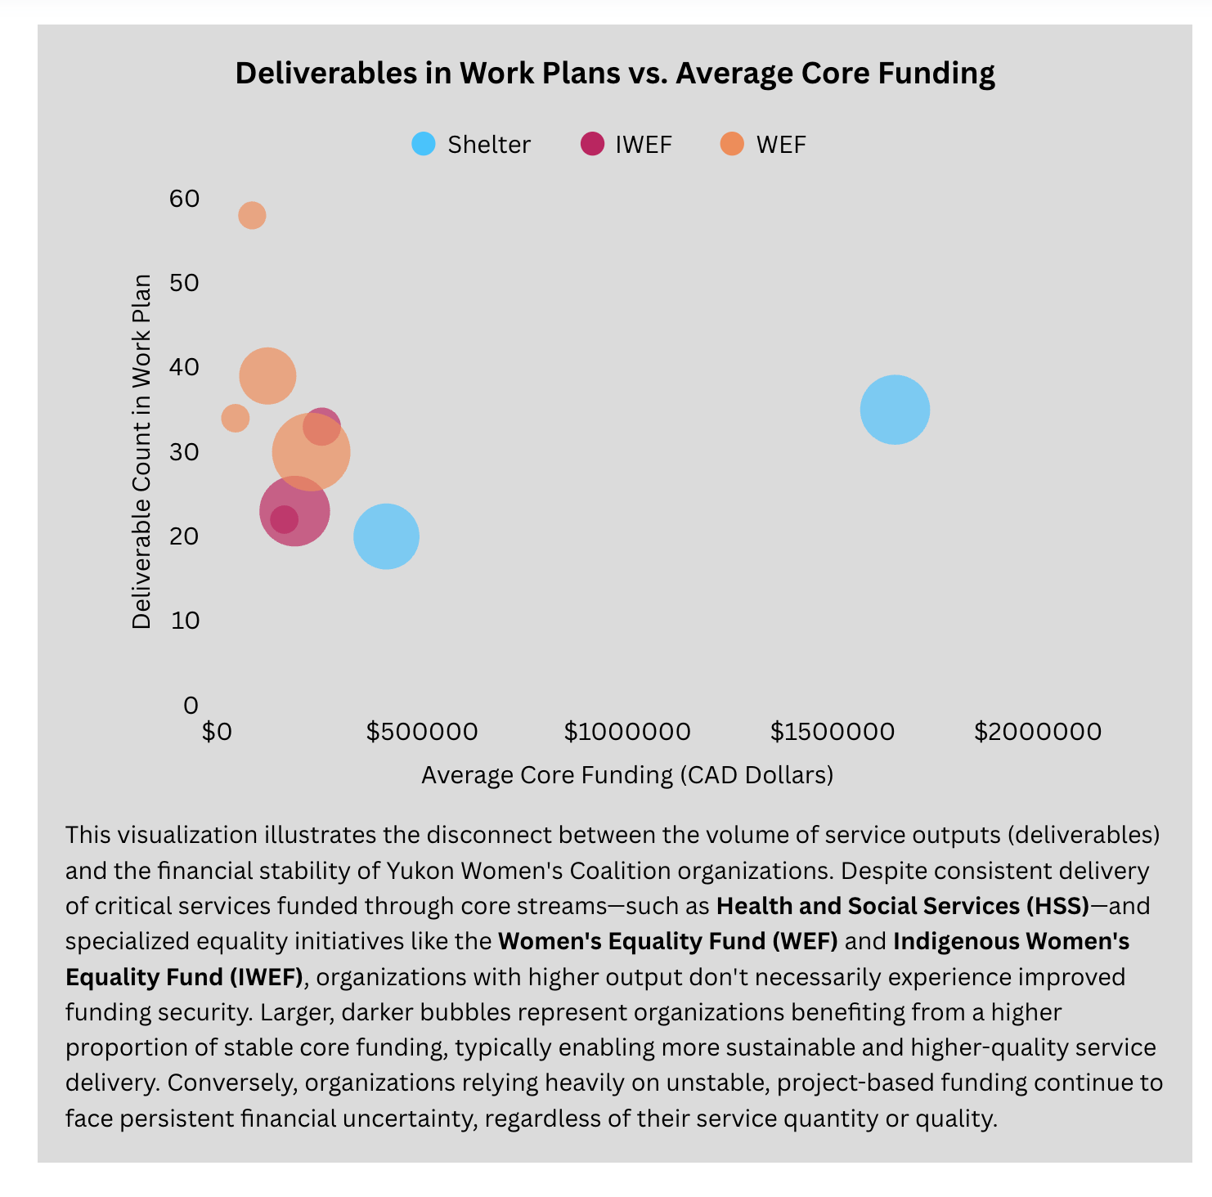

The systematic underestimation of operational overhead needs was particularly evident in the funding structures examined. While direct program expenses were generally covered by project grants, the true costs of administration, infrastructure maintenance, professional development, and data management were consistently underfunded or simply unfunded. This creates a situation where organizations must either redirect program resources to cover essential operational costs or operate with inadequate administrative support, compromising both service quality and organizational sustainability , and, subsequently, impact long-term outcomes and evaluation.

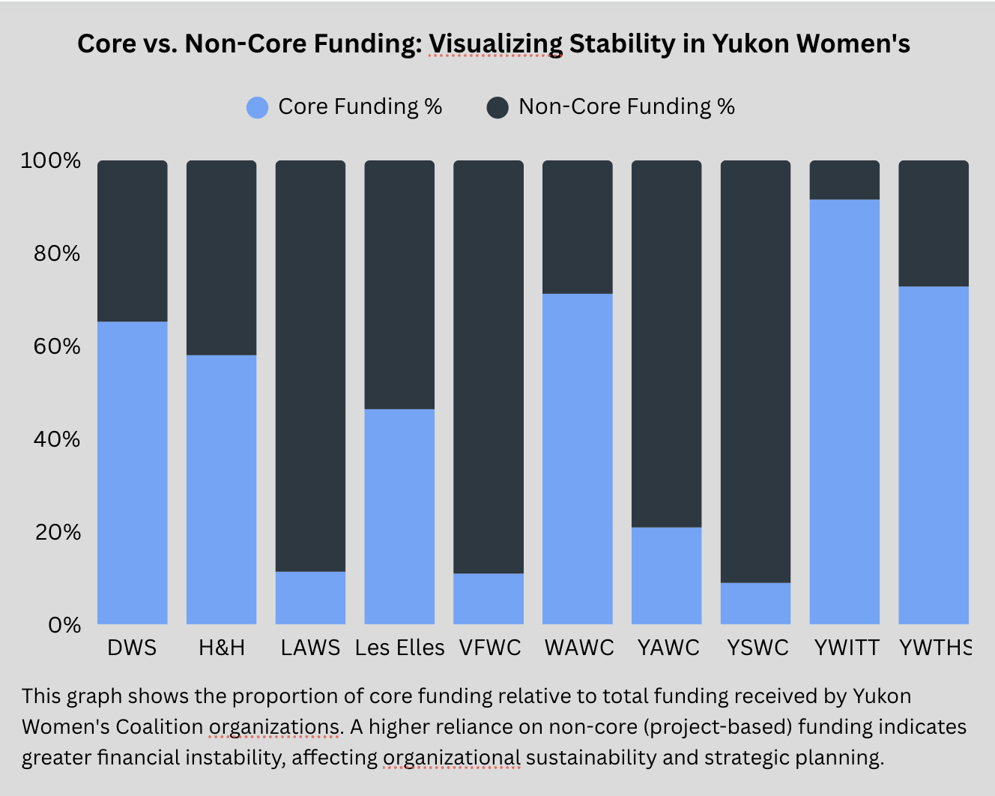﻿
During Years 1 and 2 of the NAP, funding followed previous trends and was allocated predominantly through time-limited project grants rather than sustainable operational support. This approach creates several systemic challenges:

Systemic Challenges Created by Funding Structure
Staff Overextension | Organizations reported significant strain on human resources as staff juggled multiple project-specific deliverables while maintaining core services, impacting burnout and turnover.
Administrative Inefficiency | Administrative burdens are significantly greater when funding structures necessitate applying for, reporting on, and managing the requirements associated with multiple project grants.
Implementation Discontinuity | Funding structure through time-limited projects created service interruptions when grants ended, undermining relationship-building with clients and communities—particularly problematic in GBV work where trust and consistency are critical foundations.
Strategic Planning Constraints | Organizations reported inability to engage in long-term planning or make necessary capital investments due to funding uncertainty beyond the current project cycle. Interviews with executive directors emphasized that high reporting requirements and divided attention between project-derived deliverables undermines their strategic [and collective] capacity.
Evaluation Limitations | The short-term nature of project funding complicates meaningful evaluation of program effectiveness, as many GBV prevention and intervention outcomes require longer timeframes to confer measurable change.
The Funding Paradox | Analysis revealed a concerning pattern where organizations with the fewest internal resources are often tasked with the most fragmented deliverables. Smaller organizations typically receive multiple narrowly scoped grants, each tied to a unique reporting framework, which increases administrative burden, drains limited staff capacity, and further constrains their ability to conduct meaningful evaluation or systems-level work.
Pillar-Specific Constraints | Organizations were often required to categorize their work within specific NAP pillars to receive funding, limiting deliverables to only one pillar in the first 2 years of implementation, even when their services naturally crossed multiple pillars. This artificial segmentation created silos that limited the delivery of effective and holistic GBV prevention and intervention measures.

3.3 Economic Impact of the NGO Sector
Another significant finding of this review is the substantial but largely unrecognized economic impact of Yukon's NGOs involved in GBV work. Financial analysis of YWC member organizations revealed a powerful economic multiplier effect that positions these organizations not merely as service providers but as significant contributors to Yukon's economic sustainability (see Appendix C for an expanded exploration of the economic contributions of the NGO sector).

The data demonstrates that for every $1 in territorial operational funding provided to these organizations, an additional 1.30-$10+ is leveraged into Yukon's economy in a variety of ways. For example:
- Federal Funding Attraction: Non-profit organizations access federal grants not available to territorial governments.
- Private Philanthropy: These organizations can receive donations from individuals, foundations, and corporations that further supplement government funding.
- Fee-for-Service Revenue: Some organizations generate revenue through training, consultancy, or specialized services.
- In-Kind Contributions: Organizations also contribute economic value through contributions in-kind, such as through volunteer hours, donated professional services, and community support.
- Employment Generation: The sector provides stable employment, particularly for women, contributing to income tax revenue and local spending.

The economic impacts of such territorial investments extend far beyond the direct service benefits provided. When indirect economic benefits of effective GBV intervention (such as reduced healthcare costs, decreased justice system utilization, and increased workforce participation) are considered in calculation models, the economic return of investments in GBV prevention and response is estimated to be even higher.
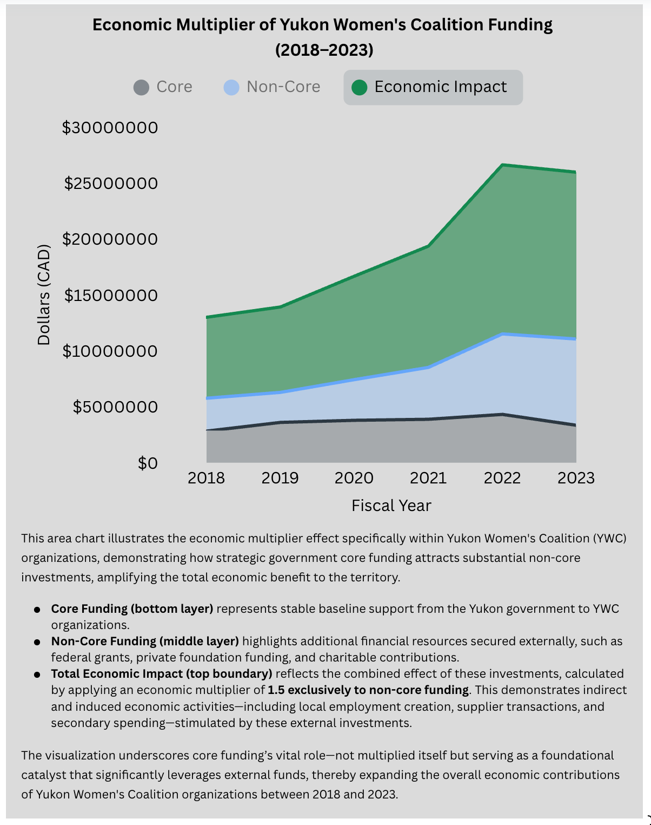
Despite these positive economic impacts, current funding approaches fail to recognize this economic multiplier effect, resulting in budget decisions that not only compromise service delivery but also represent missed opportunities for territorial economic development. This finding reframes the financial sustainability of the GBV sector as not merely a service continuity issue but a significant economic consideration for the territory as a whole.

3.4 Implementation Burden and Structural Risks
The review suggests that third-party organizations contribute substantially to the implementation of the NAP, yet they function without guaranteed or transparent financial support, creating risks to both sector integrity and the territory's ability to meet its federal obligations.

Manifestations of an Unbalanced Implementation Model
Data Generation Without Capacity Support | Frontline agencies generate the data essential for territorial compliance with federal reporting obligations yet lack the dedicated resources needed to ensure data quality and completeness.
Service Delivery Precarity | Organizations responsible for delivering critical services operate without predictable, multi-year funding commitments, limiting their ability to maintain consistent staffing and service levels.
Risk Transfer | Fiscal uncertainties and implementation risks are effectively transferred from the government to third-party organizations, which have relatively less capacity to absorb or mitigate these risks.
Capacity Degradation | The combination of increased service demands, complex reporting requirements, and unstable funding has led to concerning signs of capacity degradation, including staff turnover, reduced service hours, and waitlists for essential supports.
Rural Service Inequities | The burden falls particularly heavily on organizations serving rural communities, where operational costs are higher and funding options more limited.
In an unbalanced implementation model, there is a significant economic liability for the territory beyond the immediate GBV prevention and response capacity impacts. When third-party organizations lack the stability and capacity to function effectively, the territory not only risks non-compliance with federal agreements, but also may face negative impacts related to inefficient use of resources, and the long-term erosion of expertise within the sector (e.g. loss of sectoral knowledge and expertise due to turnover). Given the economic multiplier effect [Appendix C], underinvestment in the operational stability of these organizations represents not simply a potential service failure but a missed opportunity for territorial economic development.

3.5 Measurement Systems: Current State Assessment
Our review identified the lack of cohesion in measurement approaches currently in use across the YWC, and the clear need for a shared framework that balances accountability with practical implementation realities. More specifically, the assessment found:
- Inconsistent Metrics: Organizations collect different data points using varying definitions, making sector-wide analysis and comparison challenging.
- Output vs. Outcome Focus: Current measurement approaches primarily capture outputs (e.g., number of clients served) rather than outcomes (e.g., increased safety, reduced violence), a point echoed in both an analysis of gaps as well as historical recommendations.
- Limited Data Sharing: A lack of data-sharing precedence exists for third-party entities in the GBV sector, other than required data reporting to funders. Furthermore, the lack of the NGO GBV sector's development/resourcing of data specific infrastructure perpetuate data siloing. Sharing of data throughout the YWC would better support a coordinated, collaborative approach. For instance, better connection between the ‘frontline’ and ‘backline’ organizations, identified through a gaps analysis, is such an opportunity to maximize coordination and information sharing.
- Evaluation Resource Gaps: Few organizations have dedicated resources for robust program evaluation or outcome tracking, which translates into inability to meaningfully reflect on outcomes and inform future paths.

The Practical Impossibility of Annex D Measurement in Yukon
Despite these challenges, the review found strong interest across the sector in bolstering collaboration and developing shared measurement approaches that could strengthen both implementation and advocacy efforts. The indicator dashboard developed through this review provides a customizable framework for tracking progress across 24 domains aligned with NAP pillars. This shared measurement system represents a significant opportunity to:
- Effectively realize a collective impact model and, therefore, enhance coordinated/collaborative positioning
- Reduce reporting burden
- Support evidence-based decisions
- Enhance accountability
- Build evaluation capacity across the sector
The feasibility and value of implementing such a shared measurement system represent a key opportunity for strengthening NAP implementation in Years 3 and 4, as well as GBV sector sustainability beyond.

Analysis and Implications

4.1 NAP Implementation Tensions
The NAP sets a clear federal directive with standardized requirements across all jurisdictions; however, the distinctive demographic and geographical context of Yukon introduces profound challenges to implementation. The fundamental tensions between these national standards and Yukon’s localized needs necessitate adaptations that consider both practical limitations and strategic priorities. This section explores these critical tensions, highlighting the value of a flexible, contextually aware approach to NAP implementation in Yukon.

Comprehensive Framework vs. Limited Infrastructure
Yukon’s infrastructure for GBV services is notably limited, with only a few transition homes and service providers across the territory. This reality starkly contrasts with the NAP’s comprehensive five-pillar implementation strategy. The "Pick and Choose" flexibility clause (Section 2.11 of the agreement), which allows the Yukon to focus on different pillars annually, is a critical acknowledgment of these limitations. This clause is not merely a logistical adjustment, but a necessary adaptation to align the NAP’s ambitious goals with the practical capacity of the Yukon.

Standardized Metrics vs. Emerging Baselines
The directive to establish baseline data by September 2024 underlines the absence of comprehensive pre-existing data in Yukon, a situation not faced by most other Canadian jurisdictions. A lack of baseline data such as this presents significant challenges to adhering to standardized reporting metrics that assume a level of detail and consistency in data collection that the Yukon is not currently producing. The flexibility enabled to set a baseline is thus valuable, allowing Yukon to develop data collection capabilities that are realistically catered to its starting point. It enables a baseline, then, that is grounded in local realities.

Pillar-Specific Funding vs. Integrated Service Delivery
The ability to shift funds between pillars (Section 5.2.1), without needing federal approval, reflects a necessary flexibility for Yukon. This provision acknowledges that the rigid compartmentalization of funding into specific pillars can be counterproductive in a territory where services must be highly integrated to effectively reach dispersed populations. It allows the Yukon to allocate resources in a manner that reflects the interconnected nature of service needs, enhancing both efficiency and impact.

Cost-Sharing Challenges in Rural Contexts
The 50-50 cost-sharing model, while designed to ensure equitable financial responsibility, does not adequately account for the additional costs associated with delivering services in remote and rural areas. The inclusion of specific actions like "Inter-community Transport for Victims" underscores the unique challenges faced in these regions, where basic logistics can significantly increase the cost of service delivery. Adapting the financial models to better reflect these realities is essential for equitable and effective implementation.

4.2 Government Transparency and NAP Compliance Framework
Building on the core findings, this section analyzes the implications of current government reporting mechanisms and their alignment with NAP obligations. The analysis reveals significant structural limitations that undermine both transparency and compliance verification.

Current Government Reporting Limitations
Government reporting mechanisms related to NAP implementation currently include:
- Annual Departmental Reports: Typically provide high-level summaries without detailed financial breakdowns
- Public Accounts Documentation: Organized by department rather than by initiatives like NAP
- Bilateral Agreement Progress Reports: Submitted to the federal government but not consistently shared publicly
- Legislative Assembly Reporting: Limited to occasional ministerial statements
In the current structure, these mechanisms collectively fail to provide a clear view to how NAP funds are allocated, spent, and evaluated for effectiveness. The transparency gaps have direct implications for NAP compliance.

Compliance Verification Challenges
The bilateral agreement establishes several specific expenditure conditions (see Appendix D for more in-depth clarification surrounding administrative costs)
Prevention Minimum (25%) | Administrative Cap (10%) | Eligible Expenditure Alignment | Shared Cost Model
At least 25% of federal transfers must fund prevention initiatives | No more than 10% can be used for administrative costs | All spending must align with defined categories | The 50/50 cost-sharing between federal and territorial governments (the 50% on the part of the Yukon can be in-kind contributions, with approval)
Current Government of Yukon Public Account financial reporting structures do not consistently disaggregate expenditures by NAP pillars or financial categories such as "percentage of funding attributed to GBV Prevention," making it difficult to independently verify compliance with the 25% prevention minimum requirement. Similarly, administrative costs are not consistently isolated across departments and programs, preventing verification of compliance with the 10% administrative cap.
The current structure of the Government of Yukon's bilateral agreement compliance verification process presents an opportunity for system improvement. There is room for the government's internal financial systems to be better aligned with bilateral agreement reporting requirements. Currently, NGOs and third-party recipients invest considerable effort tracking, categorizing, and reporting their activities according to NAP pillars and expenditure categories. By streamlining these processes, the implementation chain could become more efficient, particularly benefiting smaller organizations with limited administrative capacity. Enhancing the territorial government's reporting infrastructure would create a more balanced approach to meeting compliance obligations while supporting all partners in delivering valuable services.

NAP Pillar Integration Issues
While funding conceptually aligns with the NAP pillars, many initiatives span multiple pillars in practice. Current reporting structures force artificial segmentation of services, creating a lack of congruence between operational reality and financial reporting. This is particularly problematic for:
- Indigenous-led initiatives that often take holistic approaches spanning multiple pillars
- Prevention efforts that are embedded within intervention services
- Justice initiatives that connect with support services
Executive directors pointed to this conundrum in interviews, highlighting that the forced distinction of pillars as discrete, stand-alone concepts limited service delivery that is holistic. Conversely, the current reporting mechanisms that necessitate compartmentalization of initiatives within one pillar does not accurately reflect the impact the funds have beyond that pillar. A more encompassing, dynamic reporting framework would better illustrate the true complexity and comprehensive impact of these funds across the entire service ecosystem.

Strategic Decision-Making Impacts
Transparency gaps in government reporting mechanisms not only complicate compliance verification but also negatively impact strategic decision-making. Without clear visibility into how resources are allocated and the subsequent results they achieve, it becomes difficult for both government and sector partners to:
- Identify successful approaches that are worthy of scaling
- Address emerging gaps in service provision
- Optimize resource allocation based on evidence
- Demonstrate progress toward long-term outcomes
Taken together, this analysis underlines that government transparency limitations are not merely reporting issues but fundamental strategic constraints that affect the overall effectiveness of NAP implementation. Addressing these transparency considerations, then, present an opportunity to improve upon current structures that, all things being equal, will improve overall NAP implementation.

4.3 NGO Governance and Accountability: Challenges and Opportunities
This section analyzes the current state of NGO financial governance in relation to NAP implementation, examining both challenges created by recent legislative changes and opportunities for sector-led accountability approaches.

Impact of Legislative Changes
Recent amendments to the Yukon Societies Act (2023) have significantly altered the accountability landscape for non-profit organizations in the territory:
- Reduced Public Disclosure Requirements: Mandatory public financial disclosures were removed
- Board Compensation Changes: Now permits board member compensation, creating potential conflicts of interest
- Enforcement Mechanism Weakening: Reduced tools for ensuring compliance with governance best practices
These legislative changes have effectively weakened the primary public accountability mechanisms previously present to ensure transparency in how public funds are utilized by third-party organizations (see Appendix E for an exploration Societies in Canada requiring an annual return, including financial information, with a Corporate Registries Office). A two-fold challenge, then, emerges: internal sector accountability is impaired at the same time as complicating the territory's ability to demonstrate compliance with NAP requirements through its third-party service providers.
The timing of these legislative changes coincides with increased federal transfers through the NAP, creating a situation where more public funding is flowing into organizations with reduced public accountability requirements.

Capacity and Governance Challenges
Beyond the legislative changes, YWC member organizations face several practical governance challenges.
- Capacity Limitations: Minimal administrative staffing relative to complex funding management
- Governance Transitions: Uncertainty around expected standards and practices
- Reporting Burden: Multiple uncoordinated reporting requirements from different funders
- Financial Sustainability Pressures: Short-term funding prioritizes immediate survival over governance
- Infrastructure Gaps: Limited investment in financial systems and technology
Conversations with executive directors revealed how these systemic challenges create a ripple effect throughout the system . The capacity and governance barriers they face are not isolated. Presence of such barriers create further barriers, including impacts to an organization's ability to engage in strategic planning, staff wellbeing, and service delivery. Organizations, then, are required to continuously pivot their operations and navigate increasingly complex environments with limited resources. Their narrative accounts underline the necessity of being nimble (despite having limited capacity and/or necessary operational funding) in a landscape that presents numerous obstacles, which have a cumulative impact on the sector's effectiveness and sustainability.

Opportunities for Strengthened Accountability
Despite these challenges, our analysis points to several promising approaches that could help to strengthen accountability while preserving organizational autonomy. These include the following possibilities:
- Collaborative Governance: Shared resources, templates, and best practices across organizations (similarly, these actions would further bolster the collective impact of YWC)
- Standardized Reporting: Consistent reporting formats that are specifically formulated to align with territorial and federal requirements
- Sector-Led Accountability: Peer accountability structures to complement formal regulations
- Capacity Building: Targeted investments in financial management training and systems
- Transparency as Advocacy: Enhanced financial transparency to demonstrate efficiency and impact

Strengthening NGO financial governance should be approached not as an external compliance exercise but rather as a sector-driven initiative that enhances both operational effectiveness and advocacy impact.

4.4 Economic Transparency: Beyond Service Accountability
Building on the economic multiplier finding, this section analyzes how financial transparency can be reframed as an economic imperative rather than merely a compliance issue. This perspective emerges from several interconnected insights.

Economic Framing of Transparency
Economic Multiplier Recognition | Transparent reporting would make visible the substantial economic multiplier effect ($15+ per dollar invested) of the GBV sector, strengthening the case for increased core funding as economic development.
Efficiency Optimization | Greater transparency would reveal both effective and inefficient allocation patterns, enabling more strategic investment decisions that maximize economic returns.
Federal Funding Protection | Transparent compliance reporting protects current and future federal transfers by clearly demonstrating adherence to bilateral agreement conditions.
Sector Stability as Economic Asset | The financial stability of third-party organizations represents an economic asset for the territory, as these entities not only provide essential services but also generate significant additional economic activity.
Evidence-Based Investment | Transparent outcome tracking enables identification of high-return interventions, optimizing the economic impact of limited territorial resources.

Strategic Implications of an Economic Framing of Transparency
This economic framing of transparency affords several strategic implications:
- It shifts budget decisions from viewing GBV organizations as cost centers to recognizing them as economic drivers
- It aligns service delivery goals with broader territorial economic development objectives
- It provides a stronger business case for sustainable operational funding rather than project-based grants
- It recognizes the value of administrative capacity as an investment rather than merely an overhead cost
By making visible the full economic contribution of the GBV sector, transparency mechanisms can help better position these organizations to be viewed as valued and, subsequently, funded appropriately within territorial budget processes.

4.5 Cross-Sector Transparency Framework: A Proposed Model
Based on the analysis of current challenges and opportunities, this section proposes an integrated cross-sector transparency framework that addresses gaps at both the governmental and non-governmental levels while supporting more effective NAP implementation.

Governmental Transparency Components
NAP-Specific Financial Tracking | Enhanced public accounts coding that specifically identifies and tracks NAP-related expenditures across departments
Pillar-Based Reporting | Disaggregation of NAP expenditures by the pillars (Prevention, Support for Survivors, Justice, Indigenous-Led Approaches, and Social Infrastructure) in all financial reporting.
Administrative Cost Disclosure | Clear methodology and reporting on administrative costs associated with NAP implementation to demonstrate compliance with the 10% cap.
Transfer Transparency | Detailed reporting on funds transferred to third-party organizations, including alignment with NAP objectives and bilateral agreement requirements.
Outcome Linkage | Integration of financial reporting with outcome reporting to demonstrate connections between investments and results.

Non-Governmental Transparency Components
Standardized Financial Reporting | Consistent financial reporting formats across YWC member organizations that align with both territorial and federal requirements.
Service Outcome Tracking | Shared outcome measurement approaches that demonstrate impact while respecting client confidentiality.
Economic Impact Reporting | Regular documentation and reporting of the economic multiplier effect of government investments in the GBV sector.
Governance Standards | Sector-led governance standards that ensure appropriate oversight while respecting organizational autonomy.
Capacity Development | Collaborative approaches to strengthen financial management capacity across organizations.

Cross-Sector Integration Mechanisms
Shared Indicator Dashboard | Implementation of the 24-domain indicator framework developed through this review, with both governmental and non-governmental partners contributing relevant data.
Collaborative Reporting | Integrated reporting mechanisms that reduce duplication while meeting multiple stakeholders' needs.
Transparency Working Group | A cross-sector working group to oversee implementation of enhanced transparency measures.
Annual Public Reporting | Joint publication of comprehensive reports on NAP implementation progress, including both financial and outcome metrics.
Continuous Improvement Process | Regular review and refinement of transparency mechanisms based on stakeholder feedback.
The above framework acknowledges the interconnected nature of NAP implementation and positions transparency not as an external compliance requirement but as a collaborative approach to strengthening both accountability and impact across the GBV sector.

Recommendations for Years 3 & 4 of NAP GBV Yukon Funds
Our strategic recommendations are informed by analytical insights, stakeholder feedback, and Collective Impact principles. Adopting these recommendations will improve sectoral accountability, transparency, stability, and alignment with Yukon's bilateral commitments under the National Action Plan (NAP).

1. Formalize and Sustain Collective Impact Measurement Infrastructure
Rationale:
The Yukon Government's existing Public Accounts and departmental financial reporting systems are currently insufficiently structured to transparently demonstrate compliance with explicit federal funding obligations under the NAP bilateral agreement (notably, the required minimum 25% allocation toward prevention). As a direct consequence of this structural gap, Yukon Government had little alternative but to distribute NAP funding during Years 1 and 2 exclusively through short-term, pillar-specific project grants.
This funding model inadvertently reinforced the very systemic instability and fragmentation the NAP seeks to address, perpetuating short-term thinking, heightened administrative burdens, and reduced organizational capacity for strategic collaboration and sustained impact.
Given this, the Yukon Government now faces a strategic choice:
Option A: Fundamentally restructure Public Accounts and departmental financial systems—a significant, costly, and complex undertaking—or
Option B: Fund and formalize a robust, sector-led shared measurement infrastructure through the Yukon Women's Coalition (YWC), capable of enduring beyond the current NAP funding horizon.
This review advocates for Option B. Leveraging existing sector coordination infrastructure—the current YWC coordinator and data collection processes already underway via the Yukon Bureau of Statistics (YBS)—provides a more cost-effective, responsive, and sector-informed solution. Formalizing a YWC-led shared measurement framework would:
- Directly resolve structural constraints that currently compel Yukon Government to rely on short-term, fragmented funding approaches.
- Break the cycle of instability perpetuated by temporary project funding.
- Establish a lasting, transparent accountability mechanism that aligns Yukon's federal compliance obligations with frontline realities and sector-led strategic priorities.
Recommended Actions:
- Provide explicit multi-year funding dedicated to developing and operationalizing YWC's shared measurement infrastructure, including the development of a data governance framework including indicator standardization, digital dashboard implementation, data capacity-building, and sector-wide analytics training.
- Clearly delineate and enhance the YWC coordinator's role, assigning explicit responsibilities for oversight and management of the shared measurement framework, ensuring sectoral compliance, coordination, and sustainability.
- Establish formalized funding agreements between Yukon Government and YWC, outlining roles, responsibilities, data-sharing requirements, accountability protocols, and sustained long-term funding commitments.
This structural investment transforms the Yukon GBV sector from a reactive, compliance-driven funding environment into a stable, strategically-aligned, and proactive ecosystem—precisely fulfilling the transformative intentions at the core of the National Action Plan.

2. Reform Funding Structures to Provide Multi-Year Core Operational Support
Recommendation: Reform funding structures to ensure multi-year, core operational grants with clear transparency and accountability conditions for third-party service providers, recognizing their role as economic contributors to the territory.
Rationale:
Short-term, project-based funding significantly weakens organizational capacity and strategic impact. Analysis demonstrates that stable core funding significantly increases organizational alignment with strategic NAP outcomes (+0.66 correlation), reduces administrative burdens, and strengthens overall sector effectiveness.
Implementation Components:
- Core Funding Model Development: Design sustainable multi-year approach
- Administrative Overhead Recognition: Fund true administrative costs
- Transparency Conditions: Clear, feasible expectations scaled to capacity
- Economic Impact Documentation: Track and report multiplier effects
- Rural Equity Adjustments: Account for higher rural operational costs
- Capacity Development Pool: Dedicated funding for organizational capacity
- Transition Planning: Phased approach to new funding model
Expected Outcomes:
- Enhanced service delivery stability
- Reduced administrative burden
- Improved staff retention
- Strengthened organizational capacity
- Increased economic leverage
- More equitable rural/urban service coverage
Recommended Actions:
Establish a clear tiered funding model aligned with organizational financial vulnerability and NAP alignment:
- Tier 1 (High-risk): Guaranteed two-year core operational funding, contingent on clear commitment to outcome-based indicators and transparent financial reporting.
- Tier 2 (Moderate-risk): Structured core funding with defined performance-linked conditions and capacity-building supports.
- Tier 3 (Stable Organizations): Multi-year core funding agreements tied to outcome measurement and strategic sector-wide coordination activities.

3. Establish a Collaboration & Data Capacity Pool
Recommendation: Establish a dedicated Collaboration & Data Capacity Pool of funding to support cross-agency transparency training, evaluation capacity development, and shared learning initiatives.
Rationale:
The Yukon GBV sector urgently requires explicit investment in sector-wide collaborative infrastructure and shared data capacity. Currently, there is no dedicated funding mechanism to support cross-agency data sharing, collective analytics, infrastructure development, or training.
Implementation Components:
- Resource Allocation: Dedicated NAP resources for collective capacity
- Shared Training Program: Comprehensive training in financial and data management
- Technology Infrastructure Investment: Fund necessary system upgrades
- Learning Community Development: Structured cross-organization learning
- External Expertise Access: Mechanism for specialized support
- Collaborative Project Support: Fund multi-organization initiatives
- Knowledge Repository: Centralized resource sharing
Expected Outcomes:
- Enhanced capacity for transparent financial management
- Improved data quality and consistency
- Reduced duplication of effort
- More efficient resource use
- Strengthened collective purpose
- Increased organizational resilience
Recommended Actions:
- Allocate sustainable funding specifically for collective data infrastructure development and collaboration training.
- Establish a centralized digital platform for secure data sharing, standardized indicator reporting, and real-time analytics.
- Provide ongoing technical training for organizations in data collection, management, and reporting standards aligned with the shared measurement pilot.

4. Establish Robust Financial Transparency & Standardization
Recommendation: Adopt sector-wide financial reporting standards, including mandatory audited financial statements submitted to a centralized body.
Rationale:
Recent amendments to the Yukon Societies Act have created significant governance gaps and lack of enforceability in financial accountability. This undermines both internal sector accountability and external compliance reporting.
Recommended Actions:
- Adopt sector-wide financial reporting standards, including mandatory audited financial statements submitted to a centralized body.
- Develop standardized financial reporting templates aligned with NAP pillars and Annex D outcomes.
- Create clear transparency expectations for all organizations receiving NAP funding.

5. Develop Sector Governance & Board Compensation Standards
Recommendation: Implement clear guidelines for board honorariums that maintain governance integrity, mitigate conflicts of interest, and encourage skilled participation.
Rationale:
Rising professional fees and board honorariums threaten governance transparency and organizational integrity, particularly following the 2023 Societies Act amendments allowing board compensation.
Recommended Actions:
- Implement clear guidelines for board honorariums that maintain governance integrity, mitigate conflicts of interest, and encourage skilled participation.
- Develop standardized governance policies and board training specifically addressing financial oversight and accountability.
- Create conflict of interest frameworks and disclosure requirements for all YWC member organizations.

6. Create Explicit Institutional Memory & Succession Planning
Recommendation: Fund explicit succession plans and mentorship programs to ensure continuity amid high turnover rates.
Rationale:
High turnover rates in the GBV sector threaten critical sectoral knowledge and service continuity, creating vulnerability in service delivery and advocacy.
Recommended Actions:
- Fund explicit succession plans and mentorship programs to ensure continuity of leadership.
- Develop structured knowledge management systems to capture and preserve institutional memory.
- Create cross-organizational leadership development initiatives to build future sector leaders.

7. Implement Sector-Wide Salary Equity Review
Recommendation: Conduct and publish a comprehensive salary classification review benchmarked against Yukon Government standards.
Rationale:
Workforce retention and equity challenges plague the GBV sector, with systemic underfunding relative to public sector comparators creating ongoing staffing instability.
Recommended Actions:
- Conduct and publish a comprehensive salary classification review benchmarked against Yukon Government standards.
- Develop a standardized compensation framework for the GBV sector that acknowledges expertise and experience.
- Create a multi-year plan to address wage disparities and ensure competitive compensation.

8. Develop Cross-Sector Data Sharing and Coordination
Recommendation: Establish unified data-sharing platforms and joint analytics infrastructure (including collaboration with YHRC, YCAO, and SART).
Rationale:
Siloed data systems limit the effectiveness of GBV response and prevention efforts, hindering comprehensive service delivery and outcome measurement.
Recommended Actions:
- Establish unified data-sharing platforms and joint analytics infrastructure (including collaboration with YHRC, YCAO, and SART).
- Develop data-sharing agreements that balance privacy concerns with coordination needs.
- Create cross-sector training on data integration and collaborative analysis.

9. Develop Scenario-Based Financial Risk Management Protocols
Recommendation: Implement scenario modeling (Optimistic, Status Quo, Pessimistic) as a proactive planning tool for organizational resilience and funding advocacy.
Rationale:
Funding volatility creates significant operational risks for GBV organizations, limiting their ability to plan strategically and maintain service continuity.
Recommended Actions:
- Implement scenario modeling (Optimistic, Status Quo, Pessimistic) as a proactive planning tool for organizational resilience and funding advocacy.
- Develop sector-wide risk assessment frameworks and mitigation strategies.
- Create shared contingency planning tools for funding transitions.

10. Formalize Emergency Preparedness & Continuity Planning
Recommendation: Mandate participation in structured emergency preparedness training (e.g., Canadian Women's Foundation guidelines).
Rationale:
The GBV sector remains vulnerable to crises and disruptions, potentially compromising essential services when they are most needed.
Recommended Actions:
- Mandate participation in structured emergency preparedness training (e.g., Canadian Women's Foundation guidelines).
- Develop sector-wide service continuity plans for various emergency scenarios.
- Create mutual aid agreements among YWC organizations to ensure service coverage during localized disruptions.

11. Proactively Address Emerging AI & Digital Literacy Needs
Recommendation: Invest proactively in digital literacy and AI ethics training for NGO staff, emphasizing privacy, responsible integration, and equity.
Rationale:
Technological changes, particularly in artificial intelligence and data management, create both opportunities and risks for GBV service delivery.
Recommended Actions:
- Invest proactively in digital literacy and AI ethics training for NGO staff, emphasizing privacy, responsible integration, and equity.
- Develop guidelines for ethical data collection and management in the GBV context.
- Create shared technology assessment frameworks to evaluate new tools and platforms.

12. Adopt Integrated NAP Pillar Indicators
Recommendation: Adopt integrated, transparent indicators that reflect real-world overlaps between NAP pillars rather than artificially separating interconnected work.
Rationale:
Current reporting structures force artificial segmentation of services, creating a lack of congruence between operational reality and financial reporting. A more integrated approach would better reflect the complex nature of GBV work.
Implementation Components:
- Cross-Pillar Mapping Exercise: Identify service overlap areas
- Integration Framework Development: Methodology for tracking multi-pillar services
- Financial Allocation Guidance: Guidelines for multi-pillar categorization
- Indigenous-Led Integration Model: Holistic approach reflecting Indigenous practices
- Reporting Template Redesign: Accommodate integrated measurement
- Cross-Departmental Coordination: Mechanisms for government collaboration
- Outcome Mapping: Connect integrated approaches to expected outcomes
Expected Outcomes:
- More accurate service delivery reflection
- Reduced administrative burden
- Better recognition of holistic approaches
- Enhanced ability to demonstrate interconnected impact
- Improved alignment between funding and operations
- More meaningful program evaluation
Recommended Actions:
- Formally adopt workforce stability, survivor satisfaction, and infrastructure responsiveness as explicit, standardized indicators within the shared measurement framework.
- Dedicate explicit resources toward developing culturally relevant and geographically responsive data collection methodologies.
- Integrate proxy indicator data into territorial-level compliance reporting under Annex D.

13. Implementation Timeline and Milestones
Recommendation: Establish a clear timeline with defined milestones for implementing all recommendations, with regular progress reporting to stakeholders.
Implementation Components:
- Detailed Implementation Plan: Comprehensive sequencing of actions
- Milestone Definition: Specific, measurable progress markers
- Responsible Entity Designation: Clear implementation accountability
- Resource Allocation Plan: Secured commitments for implementation
- Regular Progress Reporting: Structured stakeholder updates
- Adaptation Mechanism: Process for adjustment based on learning
- Transition Planning: Sustainability beyond current funding cycle
Expected Outcomes:
- Clear implementation accountability
- Coordinated multi-stakeholder action
- Early challenge identification
- Maintained implementation momentum
- Transparent stakeholder communication
- Seamless transition to sustained improvements
Timeline: Develop implementation plan in first quarter of Year 3, with regular updates throughout Years 3 and 4.

Conclusion and Next Steps
The comprehensive review of Yukon's implementation of the NAP reveals both challenges to address and opportunities to harness in order to strengthen the territory's approach to fund disbursement in Years 3 and 4. The findings highlight the interconnected nature of financial sustainability, transparency, accountability, and effective service delivery within the GBV sector.
With the bilateral agreement set to expire in March 2027, there is a limited window of opportunity to implement meaningful changes that could establish sustainable systems beyond the current funding framework. This timeline creates urgency for strategic action in Years 3 and 4 to maximize impact and set the foundation for long-term sectoral stability.
Central to these findings is the recognition that Yukon's GBV-focused NGOs represent not merely service providers but significant economic contributors to the territory. Again, with every dollar of operational funding generating an additional 1.30-$10 in economic activity, these organizations function as powerful economic multipliers that strengthen Yukon's fiscal position while delivering essential services. This economic lens fundamentally reframes how the sector should be viewed in policy and budget decisions.
The recommendations provided in this report address both immediate operational concerns and long-term structural reforms needed to ensure compliance with federal requirements while strengthening the sector's capacity. By implementing a shared measurement system, reforming funding structures, establishing a collaboration and data capacity pool, adopting integrated indicators, and redesigning public financial reporting, the Yukon can transform its approach to addressing GBV within the confines of NAP-based funding, and beyond
These recommendations are designed to be implemented as an integrated package rather than isolated initiatives. The intrinsic links between financial transparency, operational stability, data quality, and effective service delivery require a holistic approach that addresses systemic patterns rather than individual organizational challenges.

Immediate next steps include:
- Stakeholder Engagement: Share findings and establish collaborative implementation planning
- Resource Commitment: Secure specific implementation resources
- Implementation Team Formation: Establish a dedicated cross-sector team
- Prioritization Process: Sequence recommendations strategically
- Early Wins Identification: Implement quick-impact components
- Cross-Pillar Integration Planning: Develop strategies for addressing NAP pillar overlap
Through these actions, Yukon has the opportunity to emerge as a national leader in transparent, accountable, and effective implementation of the NAP. By recognizing and leveraging the economic impact of the GBV sector, aligning financial governance with operational realities, and strengthening cross-sector collaboration, the territory can build a sustainable approach that significantly improves outcomes for survivors while contributing to broader economic and social well-being.
This is not merely a compliance exercise but a strategic opportunity to fundamentally strengthen Yukon's approach to preventing and responding to gender-based violence—an opportunity that aligns economic imperatives with social justice goals in service of a safer, more equitable territory for all residents.

About Boreal Logic
Boreal Logic is a Yukon-based consultancy specializing in data-driven, system-level analyses tailored explicitly to rural, remote, and northern contexts. With deep expertise in navigating complex socioeconomic landscapes, Boreal Logic was engaged by the Yukon Women's Coalition (YWC) to conduct a comprehensive review of the National Action Plan (NAP) to End Gender-Based Violence implementation across Yukon Territory. This strategic review came at a critical juncture, addressing the systemic and structural gaps within the Gender-Based Violence (GBV) service landscape, particularly as the territorial and federal governments approach the midpoint of the 10-year NAP initiative.
Boreal Logic's approach emphasizes collaborative, collective impact strategies, recognizing the interconnectedness of governmental mandates and non-governmental organization (NGO) operations. Rather than evaluating isolated organizational outcomes, Boreal Logic intentionally focused on sector-wide patterns, emphasizing systemic sustainability, operational continuity, and enhanced data governance. Through rigorous document analysis, comprehensive financial pattern analyses, stakeholder consultations, and innovative development of a customizable indicator framework, Boreal Logic identified critical structural challenges, including funding model instability, fragmented measurement systems, and inconsistent governance practices.
Key findings from Boreal Logic highlight the urgent need for transitioning from fragmented, project-specific funding toward sustainable, multi-year core operational support. Boreal Logic’s financial analyses illustrated the significant economic multiplier effect of Yukon’s GBV NGOs, positioning them not merely as service providers but as vital economic drivers, leveraging substantial additional resources into the territorial economy.
Strategically, Boreal Logic has recommended developing a robust, sector-led shared measurement and data governance infrastructure through the YWC. By advocating for increased financial transparency, strengthened governance standards, and sector-wide integration of NAP pillar indicators, Boreal Logic’s recommendations form an actionable roadmap designed to enhance accountability, maximize collective impact, and ensure sustainable service delivery. Ultimately, Boreal Logic’s contribution aims to empower the YWC and GBV sector organizations to lead Yukon toward becoming a national leader in the effective, accountable, and economically sustainable implementation of the National Action Plan.


www.boreallogic.com

Disclaimer: The authors of this report were formerly employees of the Yukon Women’s Coalition (YWC) organization identified with the lowest stability index during the analysis timeframe. However, these employees successfully led several cross-sectoral collaborations, providing them with evidence-driven, comprehensive knowledge of the GBV sector and its vital role within Yukon’s social infrastructure.

Authors: Aja Mason and Ashley Hope, Boreal Logic

References
Abji, S., Major, A., Lanthier, S., & Whitmore, E. (2023). National survey of sexual violence organizations and services in Canada: Research findings. Ending Violence Association of Canada.
Canadian Research Institute for the Advancement of Women (CRIAW-ICREF). (2018). Factsheet: Women’s organizations’ capacity for action. CRIAW-ICREF.
Canadian Research Institute for the Advancement of Women (CRIAW-ICREF). (2021). A guide to building feminist intersectional solidarity. CRIAW-ICREF.
Dale, A., Maki, K., & Nitia, R. (2021). Expert engagement to address and prevent gender-based violence final report. Women's Shelters Canada.
Dawson Shelter Society. (1988). Constitution. Retrieved from https://ycor.org
Dawson Shelter Society. (2017-2023). Financial statements. Retrieved from https://ycor.org
Ending Violence Association of Canada. (2024). Findings from EVA Canada’s national questionnaire on the GBV workforce in Canada. Ending Violence Association of Canada.
Fernandes, S., & Lanthier, S. (2024). Roadmap to a stronger gender-based violence workforce. Ending Violence Association of Canada.
Government of Canada. (2025). Grant and contribution disclosure for The Dawson Shelter Society. https://search.open.canada.ca/grants/
Government of Canada. (2025). Grant and contribution disclosure for Help & Hope for Families Society. https://search.open.canada.ca/grants/
Government of Canada. (2025). Grant and contribution disclosure for Les EssentielLes. https://search.open.canada.ca/grants/
Government of Canada. (2025). Grant and contribution disclosure for Liard Aboriginal Women's Society. https://search.open.canada.ca/grants/
Government of Canada. (2025). Grant and contribution disclosure for The Victoria Faulkner Women's Centre. https://search.open.canada.ca/grants/
Government of Canada. (2025). Grant and contribution disclosure for Whitehorse Aboriginal Women's Circle. https://search.open.canada.ca/grants/
Government of Canada. (2025). Grant and contribution disclosure for Women in Trades and Technology Association. https://search.open.canada.ca/grants/
Government of Canada. (2025). Grant and contribution disclosure for Yukon Aboriginal Women's Council. https://search.open.canada.ca/grants/
Government of Canada. (2025). Grant and contribution disclosure for The Yukon Status of Women Council. https://search.open.canada.ca/grants/
Government of Canada. (2025). Grant and contribution disclosure for Yukon Women's Transition Home Society. https://search.open.canada.ca/grants/
Help & Hope for Families Society. (1986). Constitution. Retrieved from https://ycor.org
Help & Hope for Families Society. (2017-2023). Financial statements. Retrieved from https://ycor.org
Hoogendam, R., & Maki, K. (2023). Feminist brain drain: Labour issues and worker wellness in the VAW shelter sector. Women's Shelters Canada.
Kania, J., & Kramer, M. (2011). Collective impact. Stanford Social Innovation Review, 9(1), 36-41.
Les Essentielles. (1995). Constitution. Retrieved from https://ycor.org
Les Essentielles. (2024). Financial statements. Retrieved from https://ycor.org
Liard Aboriginal Women's Society. (1998). Constitution. Retrieved from https://ycor.org
Liard Aboriginal Women's Society. (2017-2023). Financial statements. Retrieved from https://ycor.org
Perreault, S. (2020). Gender-based violence: Sexual and physical assault in Canada's territories, 2018. Statistics Canada. Catalogue no. 85-002-X.
Victoria Faulkner Women's Centre, The. (1976). Constitution. Retrieved from https://ycor.org
Victoria Faulkner Women's Centre, The. (2017-2023). Financial statements. Retrieved from https://ycor.org
Whitehorse Aboriginal Women's Circle. (2003). Constitution. Retrieved from https://ycor.org
Whitehorse Aboriginal Women's Circle. (2017-2023). Financial statements. Retrieved from https://ycor.org
Women and Gender Equality Canada [WAGE]. (2022a). Canada's first national action plan to end gender-based violence. Government of Canada. https://www.canada.ca/en/women-gender-equality/gender-based-violence/intergovernmental-collaboration/national-action-plan-end-gender-based-violence/first-national-action-plan-end-gender-based-violence.html
Women and Gender Equality Canada [WAGE]. (2022b). Canada-Yukon bilateral agreement on gender-based violence. Government of Canada. https://www.canada.ca/en/women-gender-equality/gender-based-violence/intergovernmental-collaboration/bilateral-agreements/yukon-agreement.html
Women and Gender Equality Canada [WAGE]. (2023). National Action Plan to End Gender-Based Violence expected results framework. Government of Canada. https://www.canada.ca/en/women-gender-equality/gender-based-violence/intergovernmental-collaboration/bilateral-agreements/expected-results-framework.html
Women and Gender Equity Directorate. (2024a). 2023-2024 annual report on the implementation plan for Yukon's missing and murdered Indigenous women, girls and two-spirit+ people strategy for changing the story to uphold dignity and justice. Government of Yukon.
Women and Gender Equity Directorate. (2024b). Summary on the 2023–2024 annual report on the implementation plan for Yukon’s missing and murdered Indigenous women, girls, and two-spirit+ people strategy: Changing the story to uphold dignity and justice. Government of Yukon.
Women in Trades and Technology Association. (2000). Constitution. Retrieved from https://ycor.org
Women in Trades and Technology Association. (2017-2023). Financial statements. Retrieved from https://ycor.org
Yukon Aboriginal Women's Council. (1983). Constitution. Retrieved from https://ycor.org
Yukon Aboriginal Women's Council. (2017-2023). Financial statements. Retrieved from https://ycor.org
Yukon Advisory Committee on MMIWG2S+. (2023). Implementation plan for changing the story to upholding dignity and justice: Yukon's missing and murdered Indigenous women, girls and two-spirit+ people strategy. https://yukon.ca/en/implementation-plan-changing-story-upholding-dignity-and-justice-yukons-missing-and-murdered
Yukon Government. (2024). Summary on the 2023-2024 annual report on the implementation plan for Yukon's missing and murdered Indigenous women, girls and Two-Spirit+ people strategy for changing the story to uphold dignity and justice. Retrieved from https://yukon.ca/
Yukon Status of Women Council, The. (1974). Constitution. Retrieved from https://ycor.org
Yukon Status of Women Council, The. (2017-2023). Financial statements. Retrieved from https://ycor.org
Yukon Women's Transition Home Society. (1980). Constitution. Retrieved from https://ycor.org
Yukon Women's Transition Home Society. (2017–2023). Financial statements. Retrieved from https://ycor.org

Appendix A

Methodology
1. Overview and Purpose
This framework provides a living accountability structure for the GBV sector, integrating:
Collective Impact principles, ensuring a unified vision, consistent metrics, cross-sector collaboration, ongoing dialogue, and a dedicated backbone to coordinate.
Multi-Source Data and Analysis (policy/financial reviews, indicator development, scenario modeling, interactive dashboards).
Gaps Analysis and Historical Recommendations integration, preserving institutional knowledge and preventing repeated errors.
Stakeholder Engagement sessions with both Executive Directors and service users, grounding the framework in real-world insights.
The overall approach weaves together seven phases, each contributing to one or more Collective Impact (CI) conditions—Common Agenda, Shared Measurement, Mutually Reinforcing Activities, Continuous Communication, and Backbone Support.
2. Collective Impact Foundation
Collective Impact addresses complex issues like GBV through five core conditions:
Common Agenda | A shared vision and unified understanding of the challenges.
Shared Measurement | Consistent data collection and outcome-tracking across all partners.
Mutually Reinforcing Activities | Coordinated approaches that complement one another’s work.
Continuous Communication | Frequent, transparent, trust-building dialogue.
Backbone Support | A dedicated entity (or staff role) facilitating collective processes, data, and mobilization.
Prior to launching this work, readiness was confirmed through influential champions, a sense of urgency surrounding GBV issues, and sufficient resources to ensure a robust, multi-phase project (namely NAP funding).
3. Seven-Phase Methodology
Phase 1: Policy, Legislative, and Funding Analysis
Objectives | Methods | CI Alignment
Interpret key policy frameworks (e.g., bilateral agreements, NAP Annex D) and relevant legislative amendments (e.g., Societies Act).  Align local GBV mandates with broader funding and regulatory obligations. | Clause-by-clause reviews to identify constraints (e.g., minimum prevention spend, administrative caps) and flexibilities (e.g., permissible spending categories).  Developed a policy-to-practice map linking mandated targets to local workplans. | Common Agenda: Creates a unified understanding of essential policy and legislative parameters.  Backbone Support: Identifies where a coordinator can facilitate compliance, track policy changes, and unify stakeholder strategies.
Phase 2: Multi-Source Indicator Extraction and Stakeholder Engagement
Objectives | Methods | CI Alignment
Develop a Standardized Indicator Framework (a vitality framework representative of what a healthy GBV sector is in the Yukon), integrating both national considerations and local realities.  Ensure on-the-ground insights drive which indicators matter, via ED interviews and service-user surveys. | Document & Report Analysis  Examined territorial and national research, as well as relevant GBV sector NGO publications, to extract potential metrics that align with recognized policy and practical needs.  Executive Director Interviews & Service-User Surveys  Gathered leadership perspectives on the GBV sector landscape (e.g., gaps, barriers, defining a “healthy GBV sector”) and user feedback on services and unmet needs. This ensured both top-down and grassroots insights shaped the indicator framework.  Categorization of Indicators  Organized the indicators into categories reflecting the key characteristics of a healthy GBV sector. These categories served as a nexus linking National Action Plan (NAP) pillars to the specific indicators, ensuring coherence and relevance.  Initial Indicator Scoring  Applied a weighted scoring system to each potential indicator—evaluating its relevance, feasibility, and alignment with recognized policy outcomes. This step prioritized indicators that would offer the greatest value for sector-wide accountability and impact measurement. | Shared Measurement: Ensures metrics are consistent across different organizations.  Mutually Reinforcing Activities: Encourages agencies to align around common indicators, thus reducing duplication.  Continuous Communication: Fosters ongoing dialogue between EDs, service users, and the coordinating body.
Phase 3: Historical Financial Analysis (6-Year Span)
Objectives | Methods | CI Alignment
Reveal funding trends (core vs. non-core) over time and assess organizations’ financial stability.  Establish a baseline for strategic risk mitigation and future scenario planning. | Compiled 6 years of financial data from public filings, funding disclosures, and transfer-payment agreements.  Categorized each organization’s stability level based on the proportion of core vs. project-based funding. | Common Agenda (Funding Stability): Underscores the sector’s collective need for secure, sustainable resources.  Shared Measurement: Integrates financial metrics into broader sector data.  Backbone Support: Highlights where coordination is needed to standardize reporting and advocate for consistent funding.
Phase 4: Gaps Analysis & Thematic Review of Historical Recommendations
Objectives | Methods | CI Alignment
Pinpoint persistent gaps in mandates, workplans, or metrics.  Leverage past lessons from historical recommendations to guide current and future strategies. | Data-Driven Gaps Analysis  Compared organizational mandates (constitutions and work plans), bilateral agreements, and Annex D against a vitality framework (the shared measurement system or indicator framework).  Identified areas of alignment and opportunities to strengthen efforts.  Historical Recommendations Thematic Review  Compiled past recommendations from reports, testimonies, and other publicly available sources, grouping them into recurring themes.  Integration  Findings from the gaps analyses shaped iterative indicator development.  Both historical recommendations and identified gaps informed recommendations and bolstered findings from other analyses. | Common Agenda: Ensures the entire sector takes stock of repeated or outstanding lessons, preventing duplicated effort.  Shared Measurement: Situates YWC to track past recommendations.  Mutually Reinforcing Activities: Coordinates follow-up across different organizations, reducing silos.
Phase 5: Development & Final Refinement of the Integrated Indicator Framework
Objectives | Methods | CI Alignment
Elevate the initial indicator set (Phase 2) into a more cohesive, measurable, and contextually aligned framework.  Ensure that each indicator is accurately categorized and strongly tied to both local “vitality” conditions and NAP mandates. | Measurability Enhancement  Converted broad or qualitative indicators into quantifiable metrics (e.g., percentages, frequencies).  Comparative Alignment  Examined each refined indicator’s alignment with NAP Annex D’s “ultimate” performance measures.  Category Realignment & Consolidation  Merged overlapping or under-defined categories to clarify the overall structure (e.g., combining multiple funding-related categories into “Funding and Resource Allocation”).  Integration of Strategic Recommendations  Mapped “straggler” or overlooked suggestions from Phase 4 to relevant indicators, ensuring fidelity to historical lessons.  Final Validation & CSV Output  Ensured no redundancy or misalignment remained; generated a consolidated CSV linking indicators, categories, and policy references. | Shared Measurement: Delivers a final, rigorous set of indicators for sector-wide adoption.  Mutually Reinforcing Activities: Unifies organizations around the same refined metrics, boosting collective impact.  Common Agenda: Aligns local ‘vitality framework’ with national policy pillars, ensuring synergy between territorial realities and federal mandates.
Phase 6: Interactive Data Infrastructure & Dashboards
Objectives | Methods | CI Alignment
Operationalize the compiled data and analyses (policy reviews, financial insights, refined indicators, gaps, historical recommendations) into user-friendly dashboards.  Institutionalize a culture of data-driven, collaborative decision-making. | Built modular dashboards (scenario simulators, indicator explorers, funding stability trackers) with standardized data dictionaries.  Established feedback loops (e.g., monthly or quarterly reviews) to facilitate ongoing dialogue and iterative improvement. | Continuous Communication: Encourages transparent data-sharing and routine conversations about sector progress.  Backbone Support: Maintains and updates dashboards, ensuring data integrity and prompting cross-organizational engagement.
Conclusion
By incorporating these seven phases, the GBV sector benefits from:
A Common Agenda that aligns policy mandates (NAP Annex D) with Yukon’s unique realities (Vitality Framework).
Shared Measurement through carefully refined indicators and consistent financial tracking.
Mutually Reinforcing Activities derived from cross-organization synergy, preventing duplication.
Continuous Communication via dashboards, stakeholder sessions, and routine follow-ups.
Backbone Support to coordinate compliance, maintain data quality, and nurture sustained collective engagement.

Appendix B

Annex D Indicators vs. Yukon Women's Coalition Deliverables: Feasibility & Alignment Gap Analysis
This table demonstrates the critical tensions in implementing standardized National Action Plan (NAP) performance indicators within Yukon's distinct context. Significant discrepancies exist between the federally mandated Annex D indicators and the current capabilities of Yukon Women's Coalition organizations. Many performance measures required by Annex D either lack tracking infrastructure, present significant data collection challenges, or are fundamentally misaligned with current organizational deliverables. This underscores the need for flexibility, locally-adapted metrics, and targeted investment in Yukon-specific measurement infrastructure
Annex D Indicator | Current YWC Deliverables | Feasibility in Yukon | Strategic Implication
[PI 1] # of resources delivered | Partial (generalized, not numeric) | High | Possible with clear numeric tracking methods
[PI 2] # of partnerships established, by partner type | Partial (not systematically categorized) | High | Requires formal categorization and tracking of partnerships
[PI 1.1] # individuals accessing resources | Partial (inconsistent tracking) | Moderate | Significant data standardization required
[PI 2.1] % Indigenous-serving projects culturally appropriate | Not systematically measured | Moderate | Formal Indigenous-specific feedback mechanisms needed
[PI 2.2] % Indigenous-led projects | Unclear/limited Indigenous-specific reporting | High | Explicit reporting on Indigenous-led initiatives required
[PI 3.1] GBV attitudes measured | Not Tracked | Low | Requires development of Yukon-specific attitudinal survey
[PI 3.2] Victims feeling blamed by services | Not Tracked | Low | Sensitive data, requires survivor-safe feedback mechanisms
[PI 4.1] Stakeholder awareness increase | Partial (anecdotal only) | Moderate | Requires consistent stakeholder feedback tracking
[PI 5.1] Indigenous partner capacity increase | Not Tracked | Moderate | Capacity tracking specific to Indigenous partners required
[PI 6.1] Police-reported sexual violence | Partial (depends on police data) | Moderate | Better data sharing needed with law enforcement
[PI 6.2] Victims not accessing services (unsupported) | Not Tracked | Low | Privacy concerns, requires careful data collection
[PI 6.3] Positive outcomes from victim services | Partial (informal tracking) | Moderate | Formalization and standardization of feedback required
[PI 7.1] Workers in full-time jobs | Not Tracked | Moderate | Economic data tracking required within GBV sector
[PI 7.2] Women employees by occupation | Partial (not consistently reported) | Moderate | Gender-disaggregated employment tracking needed
[PI 7.3] Family violence rate | Partial (generalized police data) | Moderate | Enhanced law enforcement data sharing required
[PI 7.4] Households food-insecure | Not Tracked | Low | Significant community-level data collection required
[PI 7.5] Core housing need | Not Tracked | Low | Enhanced territorial housing data needed
[PI 8.1] Self-reported intimate partner violence | Partial (limited self-report) | Moderate | Improved victimization survey infrastructure needed
[PI 8.2] Victims of intimate partner homicide | Partial (rarely tracked) | Low | Formal tracking infrastructure needed
[PI 8.3] Sexual/physical assault self-report | Partial (limited victim self-report) | Moderate | Enhanced self-report survey infrastructure required
[PI 8.4] Psychological/emotional partner abuse | Not Tracked | Low | Requires careful data collection due to sensitivity
[PI 9.1] IPV victims reporting good health | Not Tracked | Moderate | Improved health outcome tracking for IPV survivors
[PI 9.2] Debt-to-asset ratio by family type | Not Tracked | Moderate | Requires household-level economic data collection
[PI 9.3] Sexual assault no behaviour change | Not Tracked | Low | Sensitive survivor data, requires specialized tools
[PI 9.4] Positive police interaction | Not Tracked | Low | Cross-sector data integration required

Appendix C

Briefing Note: Measuring the Contribution of the Non-Profit and NGO Sector to Yukon's GDP – A Case for Centralized Coordination
Issue
There is currently no comprehensive measurement of the non-profit and NGO sector’s contribution to Yukon's GDP. This data gap limits the ability to assess the sector’s economic impact and advocate for strategic investments. A resolution on this issue would support the establishment of a centralized coordinating or liaising body to enhance the sector’s sustainability and effectiveness.
Objective
To highlight the need for systematic data collection on the economic contributions of the NGO sector and advocate for the establishment of a centralized body to coordinate and represent the sector’s interests.
Background
The non-profit and NGO sector in Yukon plays a vital role in providing essential services, fostering community development, and supporting economic activity. Despite this, its economic contribution remains underrepresented in GDP calculations and policy considerations. The absence of standardized data collection prevents informed decision-making on funding allocations, policy development, and sector sustainability.
A clear economic valuation of this sector is critical to:
- Strengthen funding negotiations with government and private donors.
- Inform policy development and sectoral strategy.
- Foster collaboration between NGOs, businesses, and government agencies.
- Enhance economic resilience by recognizing the sector as a key employer and service provider.
Methodology for Calculation
To compute the contribution of the NGO sector to Yukon's GDP, the following formula can be applied:
Non-Profit Sector GDP Contribution=∑(Compensation of Employees+Operating Surplus+Taxes on Production−Subsidies)\text{Non-Profit Sector GDP Contribution} = \sum ( \text{Compensation of Employees} + \text{Operating Surplus} + \text{Taxes on Production} - \text{Subsidies})
Where:
- Compensation of Employees: Total wages, salaries, and benefits paid by the sector.
- Operating Surplus: The difference between revenues and expenses (excluding wages and salaries).
- Taxes on Production: Property taxes, sales taxes, and other sector-relevant taxes.
- Subsidies: Government grants or subsidies received by non-profits.
Broader GDP contributions can also be estimated through an expenditure-based approach: Total Economic Contribution=Direct Impact+Indirect Impact+Induced Impact\text{Total Economic Contribution} = \text{Direct Impact} + \text{Indirect Impact} + \text{Induced Impact}
- Direct Impact: Total revenues of non-profits minus expenses unrelated to Yukon’s economy.
- Indirect Impact: Economic activities supported through supply chains (e.g., suppliers, services hired by NGOs).
- Induced Impact: Additional economic activity generated when employees spend wages locally.
Key Data Sources
To implement this methodology, the following data sources are essential:
- Compensation of Employees
  - Source: Yukon Bureau of Statistics (YBS), Statistics Canada (NPO Satellite Account)
  - Data: Employment numbers, average annual wages, sectoral payroll estimates
- Operating Surplus
  - Source: Canada Revenue Agency (CRA) – Registered Charity Information Returns (T3010)
  - Data: Revenue sources (grants, donations, fees for services), expenses, net surplus/deficit
- Taxes on Production
  - Source: Yukon Department of Finance (taxation records)
  - Data: Business-related taxes, property taxes paid by NGOs
- Government Grants and Subsidies
  - Source: Yukon Government Budget Reports, Community Development Fund, CanNor, federal funding sources
  - Data: Total grant funding received, breakdown of operational vs. capital funding
- Indirect & Induced Impacts
  - Source: Input-Output Multipliers from Statistics Canada
  - Data: Sector-specific economic multipliers
Proposed Actions
- Sector Data Collection Initiative – Establish a working group to gather relevant financial and employment data from existing sources.
- Engagement with Government – Advocate for the inclusion of NGO sector data in Yukon economic reports and government funding evaluations.
- Establishment of a Coordinating Body – Support the development of a central entity to:
  - Coordinate data collection and reporting.
  - Facilitate sector-wide advocacy.
  - Provide capacity-building support for NGOs.
  - Strengthen partnerships with government and private sector stakeholders.
- Develop a Reporting Framework – Create an annual report on the sector’s economic contributions, aligning with national and territorial economic reporting practices.
Expected Benefits
- Evidence-Based Decision-Making: Accurate data enables targeted policy and funding decisions.
- Increased Funding and Sustainability: Demonstrating economic impact strengthens funding proposals.
- Stronger Sector Collaboration: A centralized coordinating body enhances efficiency and advocacy power.
- Improved Economic Resilience: Recognizing the sector’s role in employment and service provision helps integrate it into broader economic planning.
Conclusion
The NGO and non-profit sector is a vital but under-recognized component of Yukon’s economy. Establishing a formal methodology for measuring its GDP contribution is critical for informed decision-making, strategic investment, and long-term sector sustainability. The development of a centralized coordinating body would ensure ongoing sector representation, data management, and policy advocacy. Immediate steps should focus on data collection, government engagement, and sector-wide coordination to drive this initiative forward.
Background Information
The non-profit and non-governmental sector in Yukon plays a significant role in the territory's economy and community well-being. According to a 2022 report by Imagine Canada, the sector employs approximately 2,000 individuals, with 79% being women. These organizations offer a wide range of services, including child care, housing, health, arts, employment, and education, thereby contributing to both economic and social facets of Yukon life.
Imagine Canada
In terms of economic contribution, while specific figures for Yukon's non-profit sector are limited, national data from 2020 indicates that community non-profits accounted for $29.9 billion, or 1.4% of Canada's total GDP. Business non-profits contributed an additional $16.4 billion, representing 0.8% of the national economy. However, it's important to note that the non-profit sector's share of GDP in Yukon is below the national average.
Statistics Canada
The Government of Yukon actively supports this sector through various funding initiatives. For instance, over $1.6 million was allocated to 21 Yukon-based projects via the Community Development Fund in April 2024. These projects encompass a diverse array of community-driven initiatives aimed at fostering long-term economic and social benefits.
Yukon
Additionally, the Canadian Northern Economic Development Agency (CanNor) has invested in strengthening the capacity of Yukon's non-profit organizations. In December 2023, CanNor provided over $88,000 to the Yukon NGO Hub Society. This funding was designated for the development and delivery of governance and management training tools, as well as mentoring support for executive directors and board members of non-governmental organizations.
Government of Canada
While precise data on the non-profit sector's direct contribution to Yukon's GDP is not readily available, these organizations are integral to the territory's socio-economic fabric. They not only provide essential services but also create employment opportunities and stimulate economic activity through various community-focused projects and initiatives.
Calculating the Contribution of the Yukon's NGO and Non-Profit Sector to Yukon's GDP
To compute the contribution of Yukon's NGO and non-profit sector to Yukon's GDP, you'll need a structured approach that captures both direct and indirect economic impacts. Below is a concrete formula along with the essential data sources.
Calculation Formula:
The GDP contribution of the non-profit sector can be estimated using the Gross Value Added (GVA) approach, which is the standard method for measuring sectoral contributions to GDP.
Formula:
Non-Profit Sector GDP Contribution=∑(Compensation of Employees+Operating Surplus+Taxes on Production−Subsidies)\text{Non-Profit Sector GDP Contribution} = \sum \left( \text{Compensation of Employees} + \text{Operating Surplus} + \text{Taxes on Production} - \text{Subsidies} \right)Non-Profit Sector GDP Contribution=∑(Compensation of Employees+Operating Surplus+Taxes on Production−Subsidies)
where:
- Compensation of Employees: Total wages, salaries, and benefits paid by the sector.
- Operating Surplus: The difference between revenues and expenses (excluding wages and salaries).
- Taxes on Production: Property taxes, sales taxes, and other sector-relevant taxes.
- Subsidies: Government grants or subsidies received by non-profits.
If you want a broader expenditure-based GDP contribution, use:
Total Economic Contribution=Direct Impact+Indirect Impact+Induced Impact\text{Total Economic Contribution} = \text{Direct Impact} + \text{Indirect Impact} + \text{Induced Impact}Total Economic Contribution=Direct Impact+Indirect Impact+Induced Impact
where:
- Direct Impact: Total revenues of non-profits minus expenses unrelated to Yukon's economy.
- Indirect Impact: Economic activities supported through supply chains (e.g., suppliers, services hired by NGOs).
- Induced Impact: Additional economic activity generated when employees spend wages in the economy.

Appendix D

Briefing Note for Yukon Third-Party Recipients: Clarification on Administrative Costs Under the Canada-Yukon NAP GBV Bilateral Agreement
Overview
The Canada-Yukon Transfer Payment Agreement on implementing the National Action Plan (NAP) to End Gender-Based Violence provides important clarifications regarding administrative funding. Third-party recipients (such as NGOs) should understand the specific limitations and flexibilities regarding administrative costs clearly stated in the agreement.
Key Clauses and Interpretations
1. Administrative Cost Cap – Yukon’s 50% Contribution:
Clause 4.2.5:
"Yukon’s administration costs, including costs related to central administrative functions that support actions but are not specifically part of delivering an action outlined in Schedule B (e.g., office equipment, IT maintenance, public sector salaries), may account for a maximum of 10% of Yukon’s 50% cost share”
- Clarification:
  - The 10% administrative cost cap applies exclusively to the Yukon Government’s matched funding (its 50% share).
  - Yukon’s government must manage administrative expenditures (like office equipment, salaries unrelated to direct program delivery, IT maintenance) strictly within this cap.
2. Federal Contribution – Restrictions on Administrative Costs:
Clause 4.2.6:
"Eligible Expenditures under the federal 50% cost share can include staff and management salaries and benefits directly related to the delivery of Eligible Expenditures as outlined in Schedule B, but no federal funding can be used towards Yukon’s administration costs described in Section 4.2.5."
- Clarification:
  - The federal government explicitly prohibits using its portion of funds for general administrative costs defined in clause 4.2.5.
  - Federal funds can cover salaries and benefits only if they are directly linked to delivering activities specifically identified within the agreement’s implementation plan (Schedule B).
3. Implications for Third-Party Recipients:
- The bilateral agreement does not impose a specific administrative cap on third-party recipients (Ultimate Recipients).
- Third-party administrative expenses must align with clearly defined Eligible Expenditures outlined within the agreement. However, these are not explicitly limited by the same 10% cap imposed on Yukon Government’s internal administrative spending.
4. Strategic Considerations for NGOs:
- While no explicit administrative cap is placed directly on NGOs, the indirect implication is significant: administrative expenses funded through territorial contributions may face constraints due to Yukon’s internal 10% cap.
- NGOs have an opportunity—and strategic necessity—to clearly delineate and advocate for administrative costs directly tied to delivering eligible project activities, leveraging the allowance for program-specific administrative costs under federal rules.
- NGOs should actively seek clarity from Yukon Government on allowable administrative rates and the distinctions between general administrative costs and program-specific administrative costs to ensure compliance and optimal resource allocation.
Recommendations for Third-Party Recipients:
- Clearly categorize administrative costs as either:
  - Program-Specific Administrative Costs: Directly tied to Eligible Expenditures in Schedule B (e.g., direct program salaries, specific program administrative support).
  - General Administrative Costs: Those which may fall under Yukon Government’s restricted 10% administrative cap (e.g., general overhead, unrelated administrative salaries).
- Engage proactively with Yukon Government officials to:
  - Clarify the definitions and boundaries of allowable administrative expenses.
  - Confirm administrative cost structures before finalizing project budgets.
- Leverage the flexibility in the agreement regarding program-specific administrative costs to advocate effectively for necessary supports critical to delivering robust, impactful programs aligned with the broader goals of the NAP.
Conclusion:
The bilateral agreement provides significant latitude for third-party recipients regarding administrative funding, provided expenses directly support Eligible Expenditures. Clearly understanding and navigating these guidelines is crucial to ensuring compliance, optimizing resource allocation, and enhancing organizational sustainability.

Appendix E

Societies in Canada Requiring an annual return, including financial information, with a Corporate Registries Office
Based on the information gathered, here’s the detailed breakdown regarding societies required to file an annual return, including financial information, with a Corporate Registries Office across jurisdictions in Canada:
Jurisdictions explicitly requiring filing annual returns with financial information:
Alberta, Saskatchewan, Manitoba, Ontario, Quebec, New Brunswick, Nova Scotia, Prince Edward Island, Newfoundland and Labrador, Northwest Territories, and Nunavut.
Jurisdictions where filing annual returns, including financial information, is conditional or upon request:
Yukon (Filing financial statements is typically upon request rather than mandatory annual submission.)
British Columbia (Must provide financial statements to members and the public upon request, but no mandatory annual submission to the registry.)
Summary of Findings:
Total jurisdictions requiring annual filing with financial information: 11
Jurisdictions with conditional/upon-request filing: 2 (Yukon, British Columbia)
Implication for Yukon:
- Yukon is among a minority of jurisdictions where annual submission of financial reports to a central Corporate Registry is not explicitly mandatory, potentially indicating comparatively lighter oversight. This distinction could inform strategic recommendations about enhancing transparency or alignment with broader Canadian nonprofit oversight practices.

In the NAP document it outlines this sixth pillar as requiring a foundation of leadership, coordination and engagement; Data, research and knowledge mobilization; and Reporting and monitoring. In the Shared Measurement Framework we propose, we call this sixth pillar “Cross-cutting: Data & Accountability.
While no explicit administrative cap is placed directly on third-parties, the indirect implication is significant: administrative expenses funded through territorial contributions may face constraints due to Yukon’s internal 10% cap.
It is important to note that shifts in the Yukon Societies Act (2023) (unpacked further in section 4) make some of the publicly available data utilized unavailable going forward.
It is important to note that the bilateral agreement explicitly states that "Yukon's Implementation Plan does not have to include actions in all five pillars and foundation in any one year of this Agreement, [so long as] a minimum of 25% of the total federal funding under this Agreement must be spent by Yukon on Priority area #1 -- increasing prevention efforts" (Sections 2.11 & 4.24).
2.11 “ Yukon’s Implementation Plan” means the four-year actions of Yukon to implement the NAP to End GBV in its jurisdiction, agreed to by the Parties and attached as Schedule B. Yukon’s Implementation Plan outlines: Actions under the five pillars and the foundation of the NAP to End GBV as prioritized by Yukon. While all Yukon’s actions must fall under the five pillars and foundation of the NAP to End GBV, Yukon’s Implementation Plan does not have to include actions in all five pillars and foundation in any one year of this Agreement, other than outlined in Section 4.2.4.
The categories and indicators that emerged from an iterative development process, upon examination, aligned well with the NAP pillars. The pillars, then, were used to further organize the categories (with the associated indicators), which also conceptually grounds this shared measurement system in line with the NAP.
A shared measurement system is integral to collective impact models, as outlined by Kanier and Kramer (2011). In effect, this piece is missing from current YWC to fully realize a collective impact model.
While specific organizations are not identified here, financial records show significant differences in how organizations handle payments to individual board directors. Some individuals within specific organizations received compensation that equates to 4.5 times more than what similar organizations receive for their entire operations, based on 2020-2023 statements. This underscores our "Governance Transitions" finding - YWC organizations lack clear standards for appropriate compensation, related party dealings, and financial controls during funding shifts.

